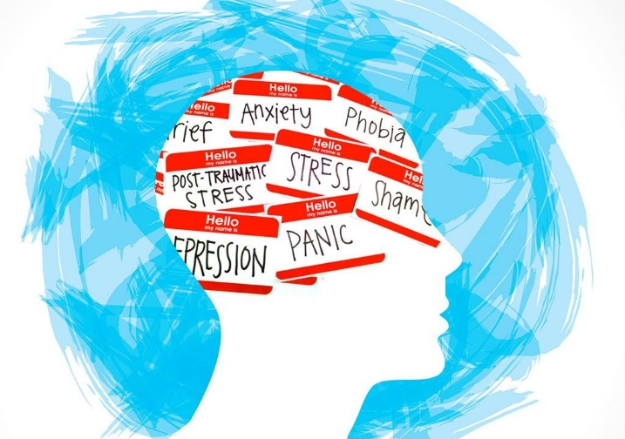
Spring 2023
SOC 492
Health and Society
MWF 9:00 – 9:50am

While physically, emotionally, and psychologically experienced, health and illness are also heavily tied to social conditions. This class uses the sociological lens to examine how and why those social conditions impact physical and mental health and well-being, including:

- The causes and consequences of health disparities based on race/ethnicity, gender, and socioeconomic status.
- Definitions and constructions of mental illness – what is ‘normal’ behavior anyway?
- The American Healthcare System – how it works and ways we can fix it.

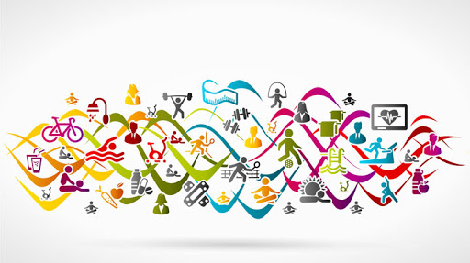

Upper-Level Social Science – No Pre-Requisite

Contact Dr. Pritchard with questions! (kayla.pritchard@sdsmt.edu)

