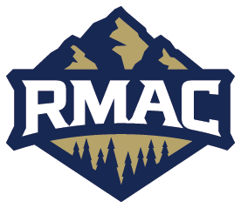



The purpose of this document is to provide guidance to South Dakota Mines (SDM) coaches, staff and student-athletes regarding the usage and care of our indoor wood court athletic facilities (i.e. Fraser and Goodell Gym). In efforts to maintain a clean surface and lengthen its life, we ask that you follow the guidance below when selecting tape and marking the floor for camps, training sessions, team practices or games.

Recommended brands of tape:
- 3M Low Tack Paper Tape
- 3M Scotch Delicate Surface
- Frog Tape Delicate Surface
- Shurtape Floor Mate 724
- 3M Scotch Blue Painters Tape Original Multi-Surface
- Frog Tape Multi-Surface
*DO NOT use duct, vinyl, athletic, masking, scotch or electrical tape to mark the floor (or walls). These products interfere with the adhesion of the gym finish.
Care of surface:
- Wipe up spills immediately
- Remove shoe/heel marks with approved cleaner (stored the closet in Goodell)
- LIFT items before moving them. Do NOT drag items across the floor.
Application and removal of tape:
- Limit the use of tape on our wood courts & remove daily if possible.
- Care must be taken when removing the tape. Lift perpendicular to the floor to avoid stress on the coating surface.
- All tape must be removed each week on Thursday night to provide for proper cleaning of the entire (bare) surface on Friday morning. Administration will coordinate this with Facilities.
- Maximum length tape can remain on the court is 7 consecutive days.

