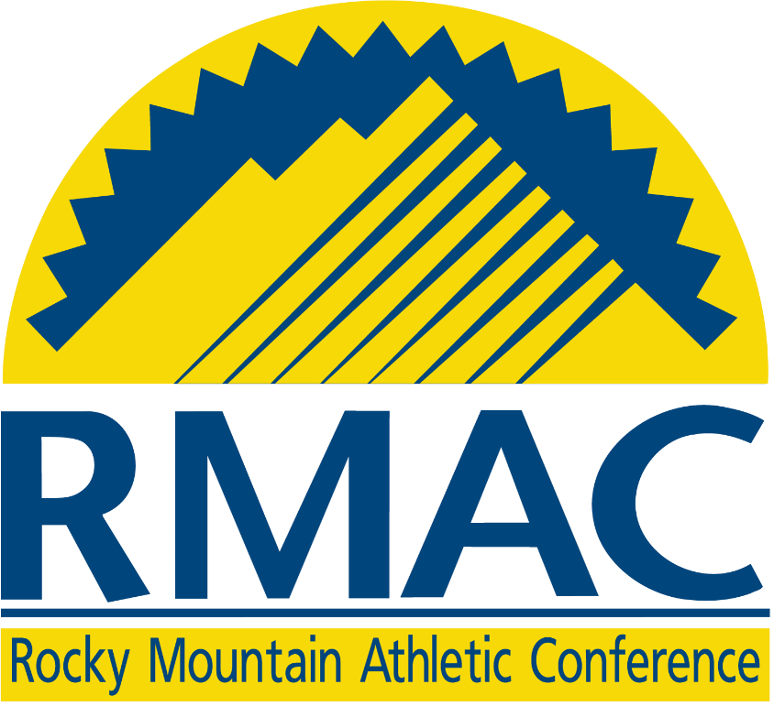

Dr. Stephen M. Jordan Degree Completion Award

Summer 2022

APPLICATION

The RMAC Degree Completion Award is available to student-athletes who have completed their eligibility and desire to complete their degree.

The criteria for application are as follows:

Student-athletes must have completed their eligibility. A student-athlete forfeits their degree completion award if they participate in a different sport from their original sport during their final semesters of attendance.

Student-athletes must have competed for a minimum of two years at an RMAC institution.

Student-athletes must be able to meet the graduation requirements of their institution in the year of the award. The year of the award is from August to August.

Student-athletes will submit a typed completed award application that includes a list of remaining coursework required for graduation, a letter of recommendation, as well as signatures from their Academic Advisor and the Faculty Athletics Representative (FAR). Applications should be submitted to the institutional Faculty Athletics Representative no later than March 25, 2022. The Faculty Athletics Representative will electronically submit the application to the conference office no later than April 8, 2022. No application will be considered without the signature of the institution’s FAR. Since the award is not GPA competitive, do not include your GPA in the application or in any supporting documentation (e.g., transcripts, letter of recommendation, etc.). Decisions regarding the awards will be based on your application and supporting documents.

Applications will be reviewed by the RMAC Academic Success Committee, which includes two FARs. This committee will review applications and select applicants who qualify for the award. Selections will be made via a conference call in late April.

Awards of up to $2,000 per semester will be available to selected applicants, with a maximum of two awards per applicant. Terms may include fall and spring. The amount of the award will be determined by the committee.

A selected applicant must complete their degree by the end of the summer 2022 term.

Selected applicants who receive awards and do not successfully complete their class load, for the term which the award was utilized, will be disqualified from consideration for a second award.

All award money will be distributed during the grant year. Awards will be distributed through the institution’s financial aid office.

RMAC DEGREE COMPLETION AWARD APPLICATION

Personal Information

____________________________________________________________________
Last First Middle

Mailing address:

City: ______________________ State: _______ ZIP: _______________

Home Phone: _____________________________

Email Address: ___________________________________________

(You will be notified by email regarding your application status no later than May 15.)

Institution: ______________________________________________

Faculty Athletic Representative (FAR): _____________________________________

Financial Aid Director (FAD): ___________________________________________

FAD Email: ____________________________________________

Are you a first-generation college graduate? _________

I: Applicant Statement

Please attach a type written, statement not more than 500 words addressing all the following in detail:

- Describe the obstacles that prohibited you from completing your degree within the time frame allotted by your eligibility.
- Describe how being a recipient of this grant will ensure your imminent graduation.
- Describe your post-graduation aspirations.

II: College Experience

Degree Program: ____________________________________________

Number of credit hours needed to complete degree by summer 2022: ______________

Please list remaining course work required for graduation:
Course Name: Credit Hours: Term to be taken:
________________________________________________________________________________________________________________________________________________________________________________________________________________________________________________________________________________________________________________________________________________________________________________________________________________________________________________________________________________________________________________________________________________________________________________________________
III: Varsity Sport Participation

Year: Varsity Sport: Institution:
________________________________________________________________________________________________________________________________________________________________________________________________________________________________________________________________________________________________
________________________________________________________________________
IV: Please attach one, single page letter of reference from a professor within your degree program to support your application.

I certify that the above information is correct and that I will complete my degree by the end of summer of 2022.

Student Name: _______________________________
Signature

Academic Advisor: _______________________________
Signature

Your signature here supports your belief that the applicant can complete all remaining course work for graduation by the end of summer 2022.

Faculty Athletics Representative: _______________________________
Signature

Date Submitted: _________________

